kk

Application Decommissioning Handbook for
An Insurance Company
Wave 7

Table of Contents

1 Introduction 8
1.1 Background 8
1.2 Objective 9
1.3 List of Applications – Cluster 7 in Scope 9
2 Demise Analysis 11
2.1 Portability Analysis 11
2.2 Risk & Criticality Analysis 11
2.3 Point of Arrival Analysis 12
3 Application in Scope 13
3.1 Finiper (Claims Voucher) 13
3.1.1 Indexes 13
3.1.2 Data Feed Dependency 13
3.1.3 Application Level Dependency 14
3.1.4 Demise Pattern 14
3.1.5 Job Card 14
3.1.6 Demise Execution Effort 15
3.2 ClaimService 16
3.2.1 Indexes 16
3.2.2 Data Feed Dependency 16
3.2.3 Application Level Dependency 17
3.2.4 Demise Pattern 17
3.2.5 Job Card 17
3.2.6 Demise Execution Effort 17
3.3 Cardif caricamento sinistri 18
3.3.1 Indexes 18
3.3.2 Data Feed Dependency 18
3.3.3 Application Level Dependency 19
3.3.4 Demise Pattern 19
3.3.5 Job Card 19
3.3.6 Demise Execution Effort 20
3.4 XXXX Bonus Drive 21
3.4.1 Indexes 21
3.4.2 Data Feed Dependency 22
3.4.3 Application Level Dependency 22
3.4.4 Demise Pattern 22
3.4.5 Job Card 22
3.4.6 Demise Execution Effort 23
3.5 Embargo 24
3.5.1 Indexes 24
3.5.2 Data Feed Dependency 24
3.5.3 Application Level Dependency 25
3.5.4 Demise Pattern 25
3.5.5 Job Card 25
3.5.6 Demise Execution Effort 27
3.6 BancheDati 28
3.6.1 Indexes 28
3.6.2 Data Feed Dependency 28
3.6.3 Application Level Dependency 29
3.6.4 Demise Pattern 29
3.6.5 Job Card 29
3.6.6 Demise Execution Effort 30
3.7 LunaIncarichi 31
3.7.1 Indexes 31
3.7.2 Data Feed Dependency 31
3.7.3 Application Level Dependency 32
3.7.4 Demise Pattern 32
3.7.5 Job card 32
3.7.6 Demise Execution Effort 33
3.8 Trasmissioni Dati Cedenti 34
3.8.1 Indexes 34
3.8.2 Data Feed Dependency 34
3.8.3 Application Level Dependency 35
3.8.4 Demise Pattern 35
3.8.5 Job Card 35
3.8.6 Demise Execution Effort 36
3.9 NPS 37
3.8.7 Indexes 37
3.8.8 Data Feed Dependency 37
3.8.9 Application Level Dependency 38
3.8.10 Demise Pattern 38
3.8.11 Job Card 38
3.8.12 Demise Execution Effort 39
3.9 Sap Console Manager 40
3.9.1 Indexes 40
3.9.2 Data Feed Dependency 40
3.9.3 Application Level Dependency 41
3.9.4 Demise Pattern 41
3.9.5 Job Card 41
3.9.6 Demise Execution Effort 42
3.10 Oracle Data Integrator 43
3.10.1 Indexes 43
3.10.2 Data Feed Dependency 43
3.10.3 Application Level Dependency 44
3.10.4 Demise Pattern 44
3.10.5 Job Card 44
3.10.6 Demise Execution Effort 45
3.11 MAG Batch Rilascio 46
3.11.1 Indexes 46
3.11.2 Data Feed Dependency 46
3.11.3 Application Level Dependency 47
3.11.4 Demise Pattern 47
3.11.5 Job card 47
3.11.6 Demise Execution Effort 48
3.12 MAG Principale 49
3.12.1 Indexes 49
3.12.2 Data Feed Dependency 49
3.12.3 Application Level Dependency 50
3.12.4 Demise Pattern 50
3.12.5 Job Card 50
3.12.6 Demise Execution Effort 51
3.13 MAG Diabolik 52
3.13.1 Indexes 52
3.13.2 Data Feed Dependency 52
3.13.3 Application Level Dependency 53
3.13.4 Demise Pattern 53
3.13.5 Job Card 53
3.13.6 Demise Execution Effort 54
3.14 MAG Connessione 55
3.14.1 Indexes 55
3.14.2 Data Feed Dependency 55
3.14.3 Application Level Dependency 56
3.14.4 Demise Pattern 56
3.14.5 Job card 56
3.14.6 Demise Execution Effort 57
3.15 MAG Ragioneria 58
3.15.1 Indexes 58
3.15.2 Data Feed Dependency 58
3.15.3 Application Level Dependency 59
3.15.4 Demise Pattern 59
3.15.5 Job Card 59
3.15.6 Demise Execution Effort 60
3.16 MAG Sinistri 61
3.16.1 Indexes 61
3.16.2 Data Feed Dependency 61
3.16.3 Application Level Dependency 62
3.16.4 Demise Pattern 62
3.16.5 Job Card 63
3.16.6 Demise Execution Effort 64
3.17 MAG Mondialservice 65
3.17.1 Indexes 65
3.17.2 Data Feed Dependency 65
3.17.3 Application Level Dependency 66
3.17.4 Demise Pattern 66
3.17.5 Job Card 66
3.17.6 Demise Execution Effort 67
3.18 MAG Commerciale 68
3.18.1 Indexes 68
3.18.2 Data Feed Dependency 68
3.18.3 Application Level Dependency 69
3.18.4 Demise Pattern 69
3.18.5 Job card 69
3.18.6 Demise Execution Effort 70
3.19 MAG Denuncia Telefonica 71
3.19.1 Indexes 71
3.19.2 Data Feed Dependency 71
3.19.3 Application Level Dependency 72
3.19.4 Demise Pattern 72
3.19.5 Job card 72
3.19.6 Demise Execution Effort 73
3.20 MAG MCC Call center sinistri 74
3.20.1 Indexes 74
3.20.2 Data Feed Dependency 74
3.20.3 Application Level Dependency 75
3.20.4 Demise Pattern 75
3.20.5 Job card 75
3.20.6 Demise Execution Effort 76
3.21 MAG Assunzioni 77
3.21.1 Indexes 77
3.21.2 Data Feed Dependency 77
3.21.3 Application Level Dependency 78
3.21.4 Demise Pattern 78
3.21.5 Job card 78
3.21.6 Demise Execution Effort 79
3.22 MAG MCC Assistenza Clienti 80
3.22.1 Indexes 80
3.22.2 Data Feed Dependency 80
3.22.3 Application Level Dependency 81
3.22.4 Demise Pattern 81
3.22.5 Job card 81
3.22.6 Demise Execution Effort 82
3.23 MAG Ced 83
3.23.1 Indexes 83
3.23.2 Data Feed Dependency 83
3.23.3 Application Level Dependency 84
3.23.4 Demise Pattern 84
3.23.5 Job card 84
3.23.6 Demise Execution Effort 85
3.24 MAG Divisione Salute 86
3.24.1 Indexes 86
3.24.2 Data Feed Dependency 86
3.24.3 Application Level Dependency 87
3.24.4 Demise Pattern 87
3.24.5 Job Card 87
3.24.6 Demise Execution Effort 88
3.25 Faxination 89
3.25.1 Indexes 89
3.25.2 Data Feed Dependency 89
3.25.3 Application Level Dependency 90
3.25.4 Demise Pattern 90
3.25.5 Job Card 90
3.25.6 Demise Execution Effort 91
3.26 Procedure chiusure mensili 92
3.26.1 Indexes 92
3.26.2 Data Feed Dependency 92
3.26.3 Application Level Dependency 93
3.26.4 Demise Pattern 93
3.26.5 Job Card 93
3.26.6 Demise Execution Effort 94
3.27 MagXXXXDs_WS_Proxy 95
3.27.1 Indexes 95
3.27.2 Data Feed Dependency 95
3.27.3 Application Level Dependency 96
3.27.4 Demise Pattern 96
3.27.5 Job Card 96
3.27.6 Demise Execution Effort 97
3.28 Selecta Freccia 98
3.28.1 Indexes 98
3.28.2 Data Feed Dependency 98
3.28.3 Application Level Dependency 99
3.28.4 Demise Pattern 99
3.28.5 Job Card 99
3.28.6 Demise Execution Effort 100
3.29 Agenzie Entrate Premi 101
3.29.1 Indexes 101
3.29.2 Data Feed Dependency 102
3.29.3 Application Level Dependency 102
3.29.4 Demise Pattern 102
102
3.29.5 Job Card 102
3.29.6 Demise Execution Effort 103
3.30 Agenzie Entrate SX 104
3.30.1 Indexes 104
3.30.2 Data Feed Dependency 104
3.30.3 Application Level Dependency 105
3.30.4 Demise Pattern 105
3.30.5 Job Card 105
3.30.6 Demise Execution Effort 106
3.31 Intrastat 107
3.31.1 Indexes 107
3.31.2 Data Feed Dependency 107
3.31.3 Application Level Dependency 108
3.31.4 Demise Pattern 108
3.31.5 Job Card 108
3.31.6 Demise Execution Effort 109
3.32 GRP 110
3.32.1 Indexes 110
3.32.2 Data Feed Dependency 110
3.32.3 Application Level Dependency 111
3.32.4 Demise Pattern 111
3.32.5 Job Card 111
3.32.6 Demise Execution Effort 112
3.33 Krill 113
3.33.1 Indexes 113
3.33.2 Data Feed Dependency 113
3.33.3 Application Level Dependency 114
3.33.4 Demise Pattern 114
3.33.5 Job Card 114
3.33.6 Demise Execution Effort 115
APPENDIX 116
Demise Pattern 116

Introduction

Background
- XXXX Application Decommissioning has 132applications in scope for assessment
- Cluster 7covers Total34 Applications and 5Applicationsare part of Integrate and 2 Applications are part of Remains and 27 Applications are part of Decommissioningworkshop.Validation workshop was conducted with stakeholders to verify Point of Arrival Analysis, Decommissioning Pattern and multiple indexes which were used to build the demise sequence.
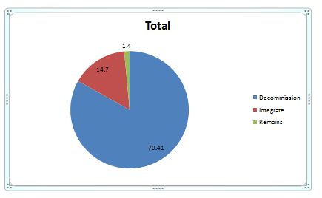
Decommission Applications 27
Total 34 Applications

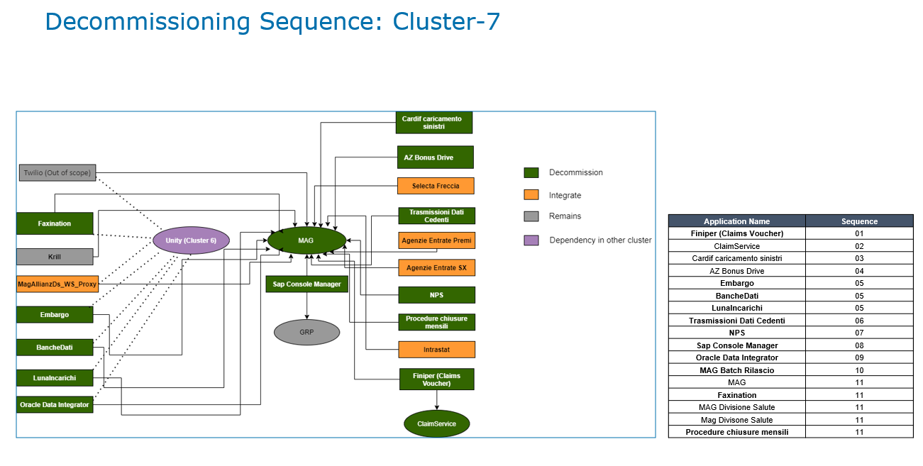

Objective
Defining a risk demystified sequence for Decommissioning along with Timelines by performing below mentioned activities.
- Identifying the Dependencies between Single Application withother applications
- Portability Index
- Risk and Criticality Index
- Technical Feasibility
- Maintainability Index
- Demise Execution Effort

List of Applications – Cluster 7 in Scope

Application name | Application Type | App Owner
Finiper (Claims Voucher) | Application | Sergio Zanardo
ClaimService | Web Service | Sergio Zanardo
Cardif caricamento sinistri | Application | Simone Dossi
XXXX Bonus Drive | Application | Simone Dossi
Embargo | Application | Simone Dossi
BancheDati | Application | Sergio Zanardo
LunaIncarichi | Core | Sergio Zanardo
Trasmissioni Dati Cedenti | Application | Simone Dossi
NPS | Application | Antonio Dal Zovo
Sap Console Manager | Application | Simone Dossi
Oracle Data Integrator | Application | Antonio Dal Zovo
MAG Batch Rilascio | Core | Renato Riva
MAG Principale | Core | Renato Riva
MAG Diabolik | Core | Antonio Dal Zovo
MAG Connessione | Core | Renato Riva
MAG Ragioneria | Core | Renato Riva
MAG Sinistri | Core | Renato Riva
MAG Mondialservice | Core | Renato Riva
MAG Commerciale | Core | Renato Riva
MAG Denuncia Telefonica | Core | Renato Riva
MAG MCC Call center sinistri | Core | Renato Riva
MAG Assunzioni | Core | Renato Riva
MAG MCC Assistenza Clienti | Core | Renato Riva
MAG Ced | Core | Renato Riva
MAG Divisione Salute | Core | Simone Dossi
Faxination | Web Service | Simone Dossi
Procedure chiusure mensili | Procedure | Renato Riva
MagXXXXDs_WS_Proxy | Web Service | Simone Dossi
Selecta Freccia | Application | Renato Riva
Agenzie Entrate Premi | Application | Renato Riva
Agenzie Entrate SX | Application | Renato Riva
Intrastat | Application | Renato Riva
Krill | Application | Renato Riva
GRP | Application | Renato Riva

Demise Analysis

Portability Analysis
Definition:
This analysis is used define the ease or difficulty in decommissioning of an application based on the interfaces and other factors.

Use of Portability Index:
To identity technically feasible candidates for building decommission sequence

Risk & Criticality Analysis
Definition:
This analysis is used to define the feasibility of decommissioning the application from a business risk & criticality perspective

Use of Risk & Criticality Index:
Risk and Criticality Index is used to take into considerations business critical factors like Legal Compliance for data retention, interactions with external regulatory bodies, access to business users etc. This also helps to define the criticality of the application from a business risk perspective that needs to be mitigated before decommissioning the application.

Indexes | Low | Medium | High | Very High
Portability Index | 0 – 0.25 | 0.26 - 0.50 | 0.51- 0.75 | 0.76 –1.0
Technical Feasibility Index | 0 – 0.25 | 0.26 - 0.50 | 0.51- 0.75 | 0.76 – 1.0
Risk & Criticality Index | 0 – 0.25 | 0.26 - 0.50 | 0.51- 0.75 | 0.76 – 1.0
Language Complexity | 0 – 0.25 | 0.26 - 0.50 | 0.51- 0.75 | 0.76 – 1.0
Stability | 0 – 0.25 | 0.26 - 0.50 | 0.51- 0.75 | 0.76 – 1.0

Point of Arrival Analysis
Definition:
Point of Arrival Analysis is the breakdown of all the application in scope into its key functions. These key functions are analysed to see if there are any functions which are not taken care by the Target Platform.

Use of Point of Arrival:
To map Decommission application functionality to target platform to identify any Gaps Analysis, Build the difference.

Application in Scope

Finiper (Claims Voucher)
Application Description: Web applications for Finiper create a Finiper Voucher following on an Appliance Protection claim. Integrated with SSO(Oazis).
Application parameters based on Interview and Data collection phase:

Type of Application | Custom Develop | Business Criticality | Low
Revenue Impact | Medium | Data Option | Retain
Support Level | Dedicated Team | Documentation | No Documentation

Indexes

Portability Index | 0.8804 | Technical Feasibility Index | 0.676
Risk & Criticality Index | 0.3 | Maintainability Index | 196.7
Language Complexity | 0.468 | Stability | 0.8

Data Feed Dependency
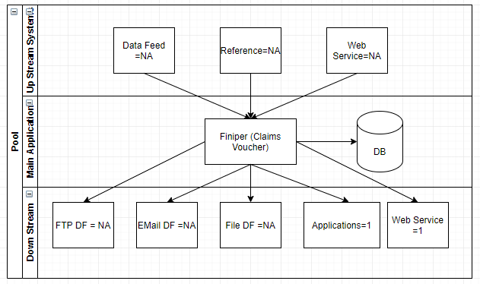

Application Level Dependency
Application name | Application Dependency
Finiper (Claims Voucher) | ClaimService
Finiper (Claims Voucher) | MAG

Demise Pattern
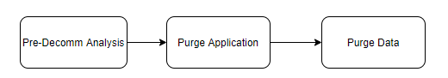

Job Card
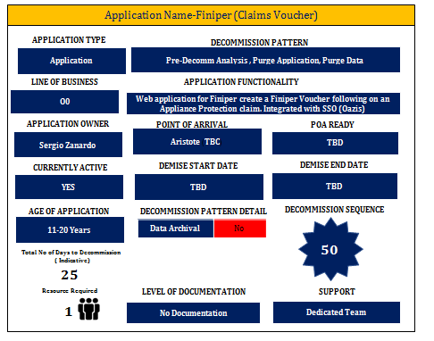

Demise Execution Effort

Total No. of days to decommission (Indicative) | 25 Days

ClaimService
Application Description: Claimservice is a web service for Finiper portal.

Application parameters based on Interview and Data collection phase:

Type of Application |  | Business Criticality | Medium
Revenue Impact | Medium | Data Option | Retain
Support Level | Dedicated Team | Documentation | Minimal Documentation

Indexes
Portability Index | 0.8609 | Technical Feasibility Index | 0.53
Risk & Criticality Index | 0.48 | Maintainability Index | 182.91
Language Complexity | 0.546 | Stability | 0.8

Data Feed Dependency
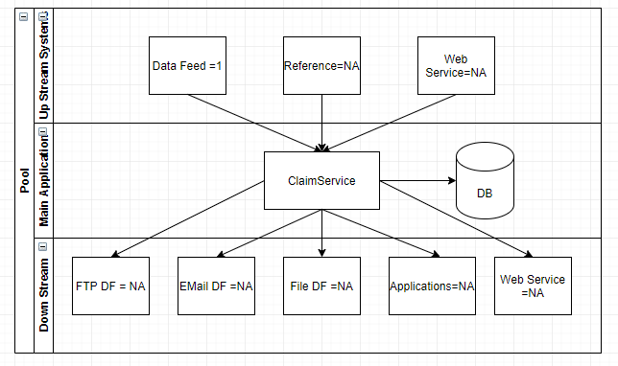

Application Level Dependency
Application name | Application Dependency
ClaimService | Finiper (Claims Voucher)

Demise Pattern
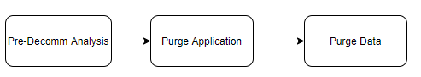

Job Card
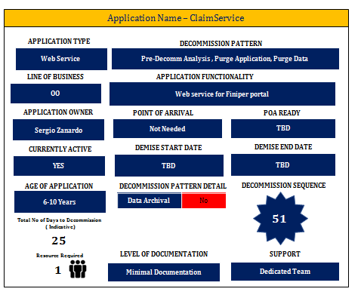

Demise Execution Effort
Total No. of days to decommission (Indicative) | 25 Days

Cardif caricamento sinistri
Application Description: It is a Windows service for Cardif claims management and sends Case data to Cardif.

Application parameters based on Interview and Data collection phase:

Type of Application | Custom develop | Business Criticality | Low
Revenue Impact | Low | Data Option | Retain
Support Level | Shared Team | Documentation | No Documentation

Indexes
Portability Index | 1 | Technical Feasibility Index | 0.178
Risk & Criticality Index | 0.6 | Maintainability Index | 194.71
Language Complexity | 0.498 | Stability | 0.8

Data Feed Dependency
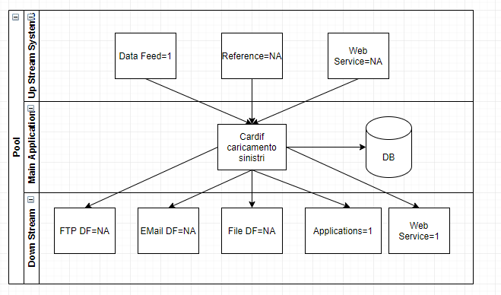

Application Level Dependency
Application name | Application Dependency
Cardif caricamento sinistri | MAG

Demise Pattern

Job Card
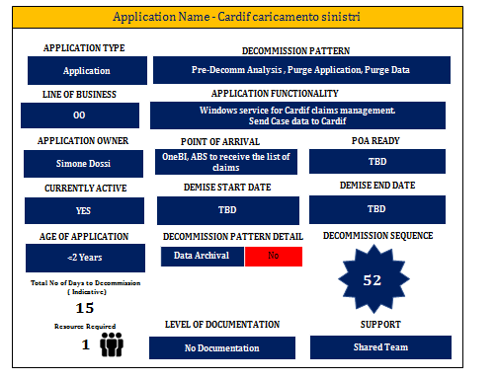

Demise Execution Effort
Total No. of days to decommission (Indicative) | 15 Days

XXXX Bonus Drive
Application Description: XXXX Bonus Drive is windows service for the XXXX Bonus Drive management. It is a Single backend application. Given application receives subscribed file information pertaining to issues with client and intercompany Invoices. Client invoices files are managed in legacy system and shared to XXXX via FTP, whereas Intercompany invoice files is handles manually. XXXX Partner create 4 files (2 csv, 2 text) having aggregate value and these files are send to distribution lists. It also creates daily 3 reports with calculations on the current month data.
Application parameters based on Interview and Data collection phase
Type of Application | Custom develop | Business Criticality | High
Revenue Impact | High | Data Option | Retain
Support Level | Shared Team | Documentation | Minimal Documentation

Indexes

Portability Index | 0.7945 | Technical Feasibility Index | 0.53
Risk & Criticality Index | 0.97 | Maintainability Index | 187.57
Language Complexity | 0.46 | Stability | 0.8

Data Feed Dependency
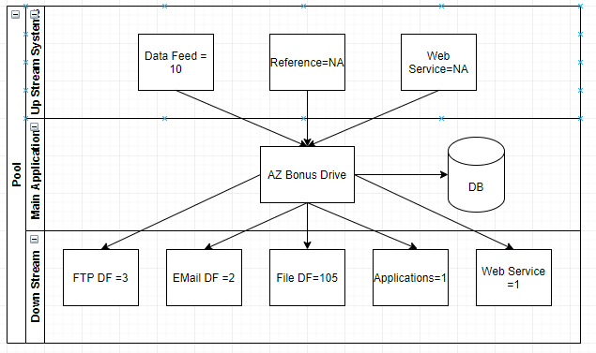

Application Level Dependency
Application name | Application Dependency
XXXX Bonus Drive | MAG

Demise Pattern

Job Card
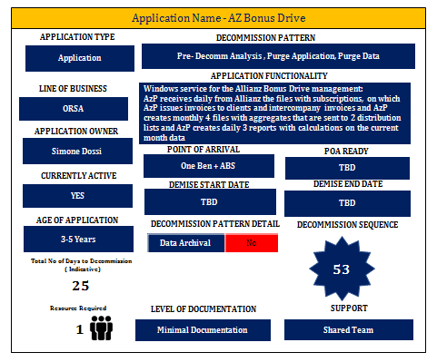

Demise Execution Effort
Total No. of days to decommission (Indicative) | 25 Days

Embargo
Application Description: Embargo is an Anti-Racket and Sanction system.
Application parameters based on Interview and Data collection phase:

Type of Application | Custom develop | Business Criticality | Low
Revenue Impact | Low | Data Option | Retain
Support Level | Shared Team | Documentation | No Documentation

Indexes

Portability Index | 0.9288 | Technical Feasibility Index | 0.472
Risk & Criticality Index | 0.45 | Maintainability Index | 194.37
Language Complexity | 0.514 | Stability | 0.8

Data Feed Dependency
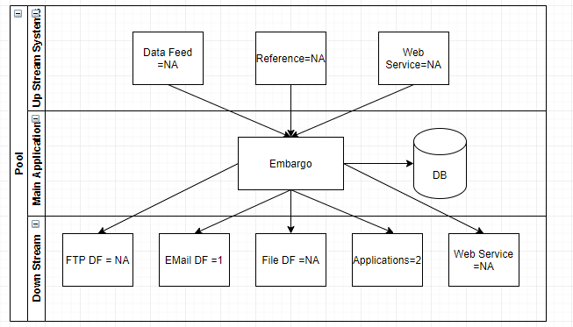

Application Level Dependency
Application name | Application Dependency
Embargo | MAG
Embargo | Unity (cluster 6)

Demise Pattern

Job Card

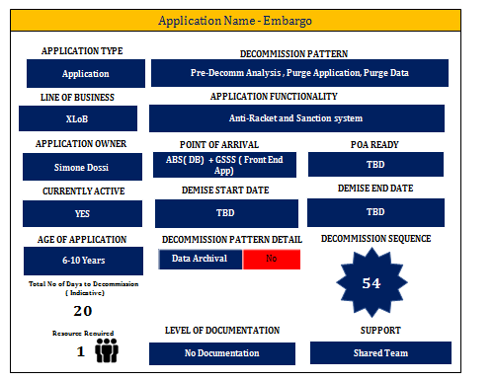

Demise Execution Effort
Total No. of days to decommission (Indicative) | 20 Days

BancheDati
Application Description: BancheDati is a Coverage data DB. Intranet web application to search beneficiary data sources for eligibility check used by operational department, to check policy number, name. Some are internal DB and some are external Web Services.
Application parameters based on Interview and Data collection phase:
Type of Application | Custom develop | Business Criticality | High
Revenue Impact | High | Data Option | Retain
Support Level | Dedicated Team | Documentation | Minimal Documentation

Indexes

Portability Index | 0.8092 | Technical Feasibility Index | 0.676
Risk & Criticality Index | 0.62 | Maintainability Index | 187.4
Language Complexity | 0.468 | Stability

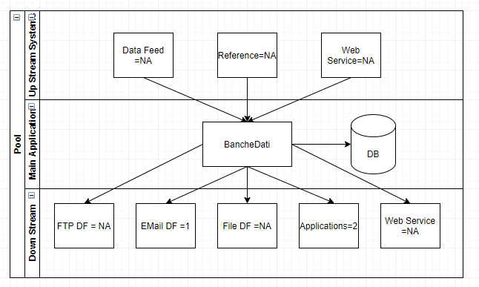
Data Feed Dependency

Application Level Dependency
Application name | Application Dependency
BancheDati | MAG
BancheDati | Unity (cluster 6)

Demise Pattern

Job Card

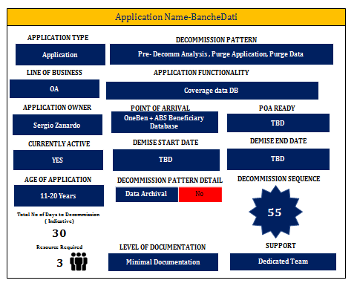

Demise Execution Effort
Total No. of days to decommission (Indicative) | 30 Days

LunaIncarichi
Application Description: Update of claim/expenditure data Is the application used to align expenditures Unity & legacy system. The application is scheduled every 5 minutes.
Application parameters based on Interview and Data collection phase:

Type of Application | Custom develop | Business Criticality | Medium
Revenue Impact | High | Data Option | Retain
Support Level | Dedicated Team | Documentation | No Documentation

Indexes
Portability Index | 0.902 | Technical Feasibility Index | 0.53
Risk & Criticality Index | 0.6 | Maintainability Index | 196.87
Language Complexity | 0.46 | Stability | 0.2

Data Feed Dependency
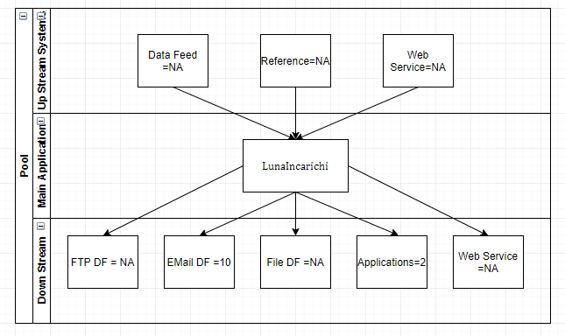

Application Level Dependency
Application name | Application Dependency
LunaIncarichi | MAG
LunaIncarichi | Unity (cluster 6)

Demise Pattern

Job card

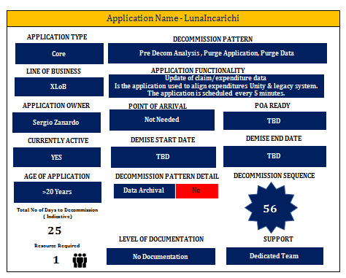

Demise Execution Effort
Total No. of days to decommission (Indicative) | 25 Days

Trasmissioni Dati Cedenti
Application Description: Trasmissioni Dati Cedenti creates and manages claims data and case data is send to XXXX Italy.
Application parameters based on Interview and Data collection phase:

Type of Application | Custom Develop | Business Criticality | Low
Revenue Impact | Medium | Data Option | Retain
Support Level | Shared Team | Documentation | No Documentation

Indexes

Portability Index | 0.949 | Technical Feasibility Index | 0.618
Risk & Criticality Index | 0.6 | Maintainability Index | 194.2
Language Complexity | 0.522 | Stability | 0.8

Data FeedDependency
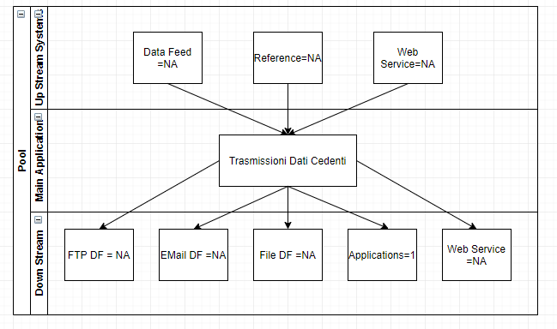

Application Level Dependency
Application name | Application Dependency
Trasmissioni Dati Cedenti | MAG

Demise Pattern

Job Card

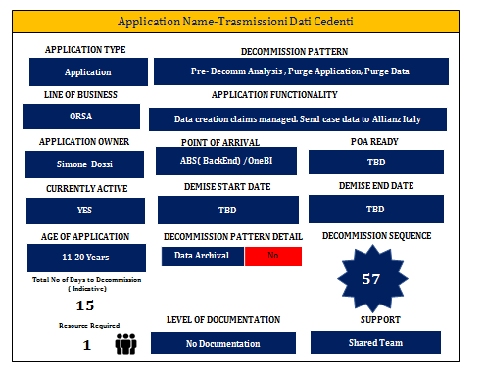

Demise Execution Effort/Cost
Total No. of days to decommission (Indicative) | 15 Days

3.9 NPS

Application Description: NPS is used to verify and produce statistics on customer satisfaction.
Application parameters based on Interview and Data collection phase

Type of Application | ETL Procedure | Business Criticality | Not Available
Revenue Impact | Not Available | Data Option | Not Available
Support Level | Not Available | Documentation | Not Available

Indexes

Portability Index | Not Applicable | Technical Feasibility Index | Not Applicable
Risk & Criticality Index | Not Applicable | Maintainability Index | Not Applicable
Language Complexity | Not Applicable | Stability | Not Applicable

Data Feed Dependency
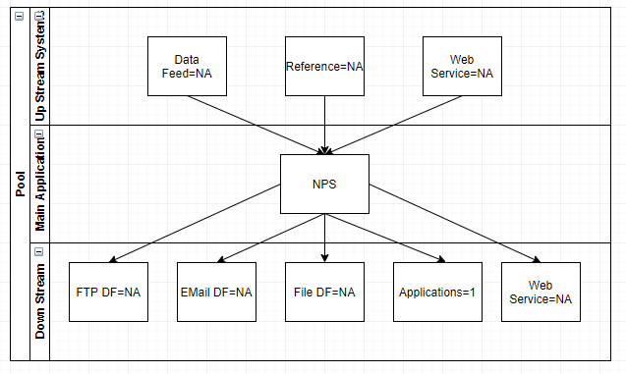

Application Level Dependency
Application name | Application Dependency
NPS | MAG

Demise Pattern
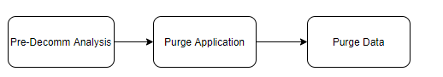

Job Card

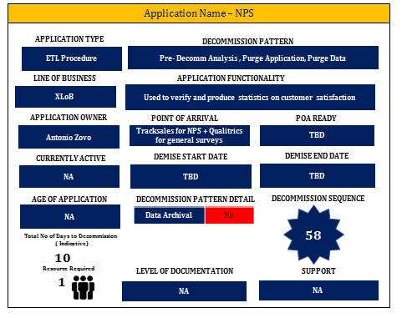

Demise Execution Effort
Total No. of days to decommission (Indicative) | 10 Days

Sap Console Manager
Application Description: Application to manage the SAP data transfer from Legacy system to SAP DB.

Application parameters based on Interview and Data collection phase:

Type of Application | Custom develop | Business Criticality | Medium
Revenue Impact | Medium | Data Option | Archival
Support Level | Shared Team | Documentation | No Documentation

Indexes

Portability Index | 0.7999 | Technical Feasibility Index | 0.56
Risk & Criticality Index | 0.36 | Maintainability Index | 201.91
Language Complexity | 0.432 | Stability | 0.2

Data Feed Dependency

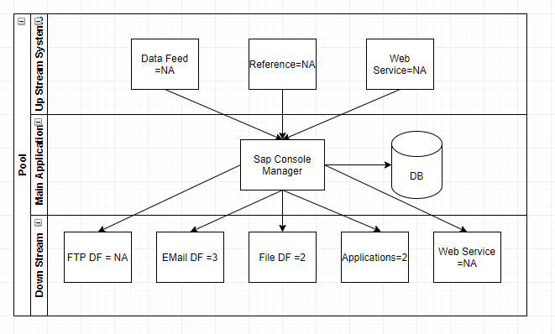

Application Level Dependency
Application name | Application Dependency
Sap Console Manager | MAG
Sap Console Manager | GRP

Demise Pattern

Job Card

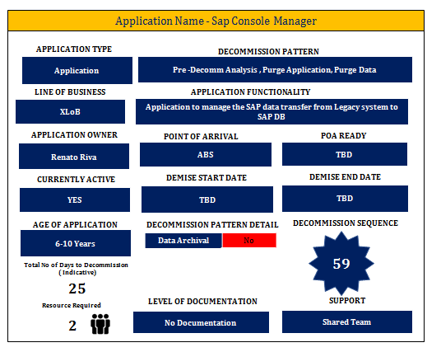

Demise Execution Effort

Total No. of days to decommission (Indicative) | 25 Days

Oracle Data Integrator

Application Description: Oracle Data Integrator is an Oracle Suite for ETL procedures.
Application parameters based on Interview and Data collection phase:

Type of Application | Not Available | Business Criticality | Not Available
Revenue Impact | Not Available | Data Option | Not Available
Support Level | Not Available | Documentation | Not Available

Indexes

Portability Index | Not Applicable | Technical Feasibility Index | Not Applicable
Risk & Criticality Index | Not Applicable | Maintainability Index | Not Applicable
Language Complexity | Not Applicable | Stability | Not Applicable

Data Feed Dependency
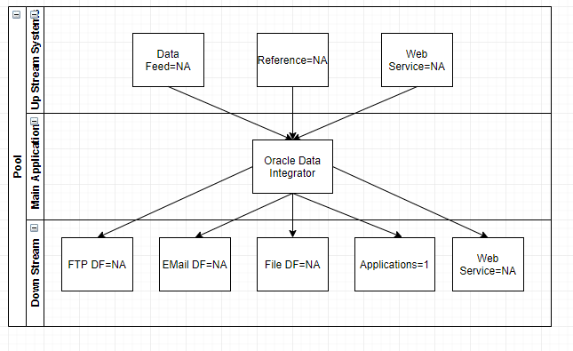

Application Level Dependency
Application name | Application Dependency
Oracle Data Integrator | MAG
Oracle Data Integrator | Unity ( Cluster 6)

Demise Pattern

Job Card

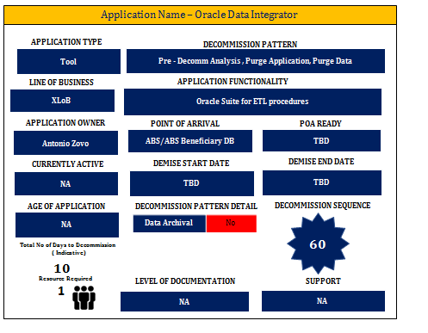

Demise Execution Effort
Total No. of days to decommission (Indicative) | 10 Days

MAG Batch Rilascio
Application Description: Application used to publish the application in to production environment.
Application parameters based on Interview and Data collection phase:

Type of Application | Custom develop | Business Criticality | Medium
Revenue Impact | Low | Data Option | Retain
Support Level | Shared Team | Documentation | No Documentation

Indexes

Portability Index | 0.9741 | Technical Feasibility Index | 0.472
Risk & Criticality Index | 0.13 | Maintainability Index | 194.37
Language Complexity | 0.514 | Stability | 0.2

Data Feed Dependency
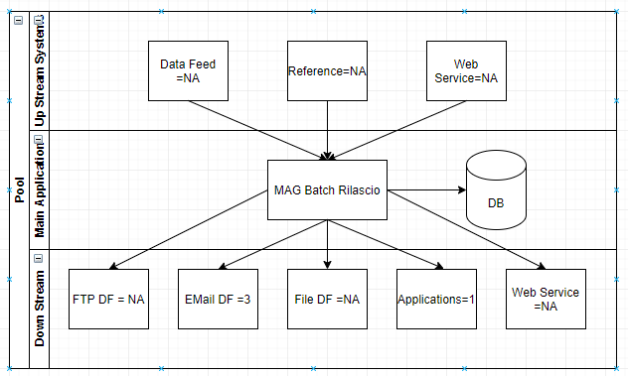

Application Level Dependency
Application name | Application Dependency
MAG Batch Rilascio | MAG

Demise Pattern
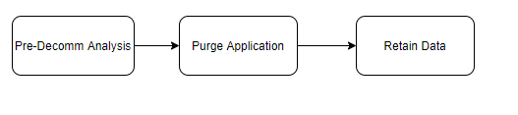

Job card

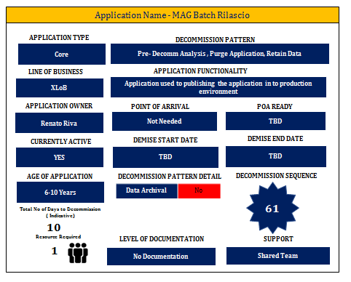

Demise Execution Effort
Total No. of days to decommission (Indicative) | 10 Days

MAG Principale
Application Description: Consolle to launch alle the legacy system module.
Application parameters based on Interview and Data collection phase
Type of Application | Custom develop | Business Criticality | Very High
Revenue Impact | Very High | Data Option | NA
Support Level | Dedicated Team | Documentation | No Documentation

Indexes
Portability Index | 0.7274 | Technical Feasibility Index | 0.6
Risk & Criticality Index | 0.93 | Maintainability Index | 211.93
Language Complexity | 0.428 | Stability | 0.6

Data Feed Dependency
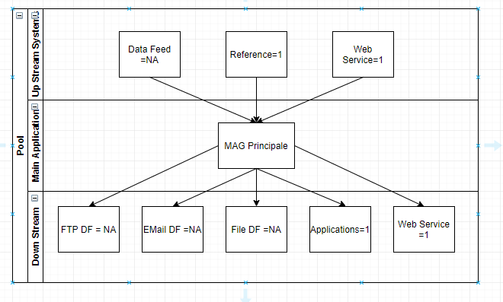

Application Level Dependency
Application name | Application Dependency
MAG Principale | - Unity  - SAP Console Manager,  - Faxination, Krill  - Embargo  - Banchedati  - Lunalncarichi  - Oracle Data Integrator  - Cardif sinistri  - XXXX Bonus Drive  - Selecta Freccia  - Trasmissioni Dati Cedenti  - Agenzie Entrate Premi  - Agenzi Extrate SX,  - NPS, Procedure chiusure  - Intrastat  - Finiper  - ClaimService

Demise Pattern
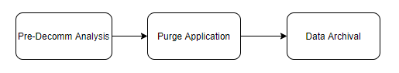

Job Card
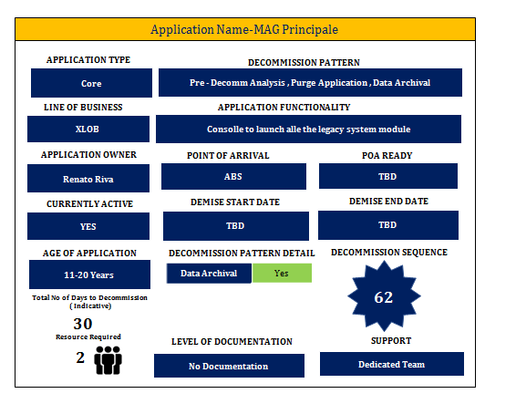

Demise Execution Effort
Total No. of days to decommission (Indicative) | 30 Days

MAG Diabolik
Application Description: Legacy System module to manage the assistance platform activities.

Application parameters based on Interview and Data collection phase:

Type of Application | Custom develop | Business Criticality | Low
Revenue Impact | Low | Data Option | Retain
Support Level | Dedicated Team | Documentation | Minimal Documentation

Indexes

Portability Index | 0.8004 | Technical Feasibility Index | 0.588
Risk & Criticality Index | 0.28 | Maintainability Index | 180.19
Language Complexity | 0.662 | Stability | 0.8

Data Feed Dependency
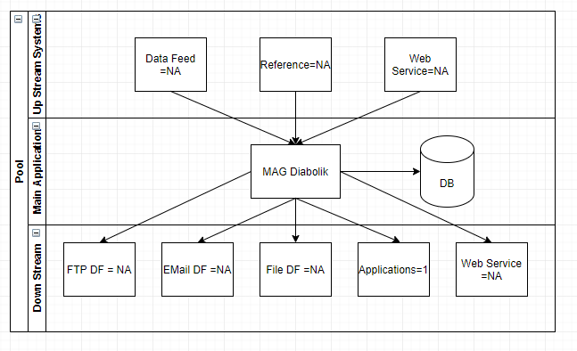

Application Level Dependency
Application name | Application Dependency
MAG Diabolik | - Unity, SAP Console Manager  - Faxination  - Krill, Embargo  - Banchedati  - Lunalncarichi  - Oracle Data Integrator  - Cardif sinistri  - XXXX Bonus Drive  - Selecta Freccia  - Trasmissioni Dati Cedenti  - Agenzie Entrate Premi  - Agenzi Extrate SX  - NPS  - Procedure chiusure  - Intrastat  - Finiper  - ClaimService

Demise Pattern
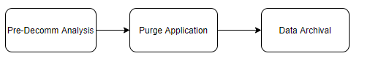

Job Card
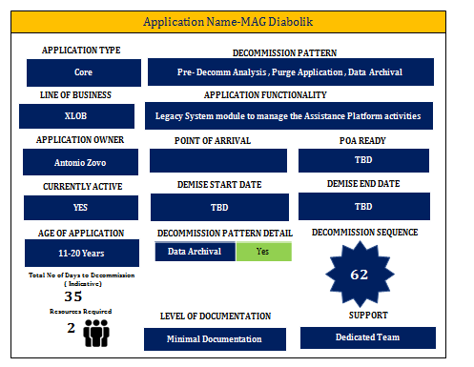

Demise Execution Effort
Total No. of days to decommission (Indicative) | 35 Days

MAG Connessione
Application Description: Application used to connect the entire MAG module.
Application parameters based on Interview and Data collection phase
Type of Application | Custom develop | Business Criticality | Very High
Revenue Impact | Very High | Data Option | Archival
Support Level | Dedicated Team | Documentation | No Documentation

Indexes
Portability Index | 0.7274 | Technical Feasibility Index | 0.6
Risk & Criticality Index | 0.93 | Maintainability Index | 211.93
Language Complexity | 0.428 | Stability | 0.6

Data Feed Dependency
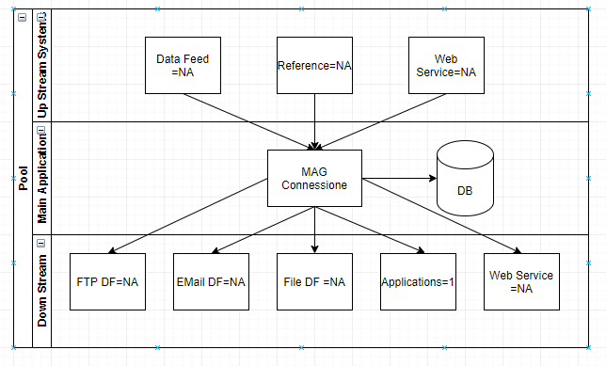

Application Level Dependency
Application name | Application Dependency
MAG Connessione | - Unity,  - SAP Console Manager,  - Faxination, Krill,  - Embargo,  - Banchedati, Lunalncarichi,  - Oracle Data Integrator,  - Cardif sinistri,  - XXXX Bonus Drive ,  - Selecta Freccia ,  - Trasmissioni Dati Cedenti ,  - Agenzie Entrate Premi,  - Agenzi Extrate SX,  - NPS,  - Procedure chiusure ,  - Intrastat ,  - Finiper ,  - ClaimService

Demise Pattern
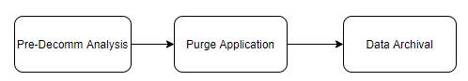

Job card

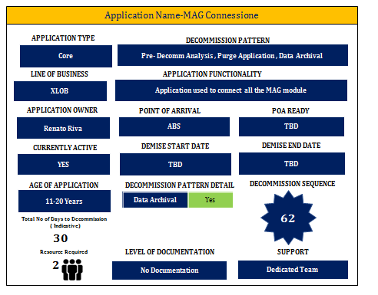

Demise Execution Effort
Total No. of days to decommission (Indicative) | 30 Days

MAG Ragioneria
Application Description: Legacy System module to manage the finance activities.
Application parameters based on Interview and Data collection phase:

Type of Application | Custom develop | Business Criticality | Very High
Revenue Impact | Very High | Data Option | Archival
Support Level | Dedicated Team | Documentation | No Documentation

Indexes

Portability Index | 0.6781 | Technical Feasibility Index | 0.6
Risk & Criticality Index | 0.93 | Maintainability Index | 211.93
Language Complexity | 0.428 | Stability | 0.6

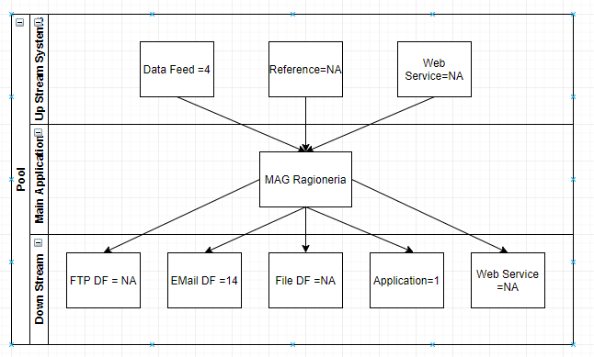
Data Feed Dependency

Application Level Dependency
Application name | Application Dependency
MAG Ragioneria | - Unity,  - SAP Console Manager,  - Faxination, Krill,  - Embargo,  - Banchedati, Lunalncarichi,  - Oracle Data Integrator,  - Cardif sinistri,  - XXXX Bonus Drive ,  - Selecta Freccia ,  - Trasmissioni Dati Cedenti ,  - Agenzie Entrate Premi,  - Agenzi Extrate SX,  - NPS,  - Procedure chiusure,  - Intrastat ,  - Finiper ,  - ClaimService

Demise Pattern

Job Card

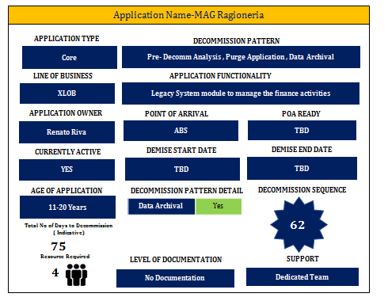

Demise Execution Effort
Total No. of days to decommission (Indicative) | 75 Days

MAG Sinistri
Application Description: Legacy System module to manage the claims activities.

Application parameters based on Interview and Data collection phase:

Type of Application | Custom develop | Business Criticality | Very High
Revenue Impact | Very High | Data Option | Archival
Support Level | Shared Team | Documentation | No Documentation

Indexes
Portability Index | 0.7306 | Technical Feasibility Index | 0.736
Risk & Criticality Index | 0.73 | Maintainability Index | 211.77
Language Complexity | 0.414 | Stability | 0.2

Data Feed Dependency
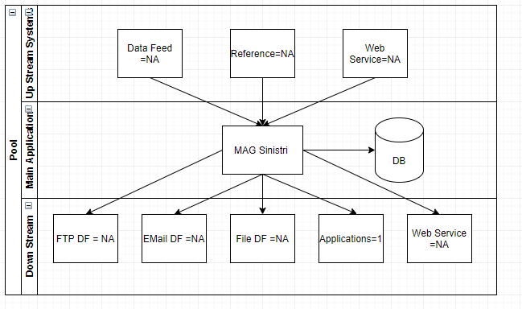

Application Level Dependency
Application name | Application Dependency
MAG Sinistri | - Unity,  - SAP Console Manager,  - Faxination, Krill, Embargo,  - Banchedati,  - Lunalncarichi,  - Oracle Data Integrator,  - Cardif sinistri,  - XXXX Bonus Drive ,  - Selecta Freccia ,  - Trasmissioni Dati Cedenti ,  - Agenzie Entrate Premi,  - Agenzi Extrate SX,  - NPS, Procedure chiusure ,  - Intrastat ,  - Finiper ,  - ClaimService

Demise Pattern

Job Card

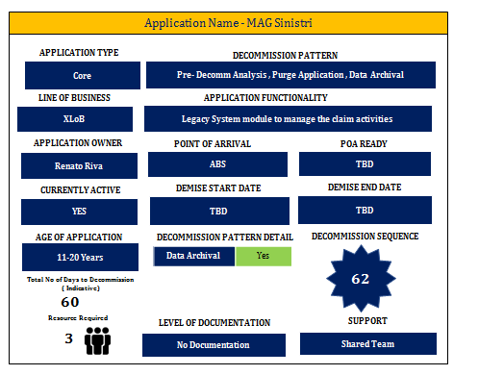

Demise Execution Effort
Total No. of days to decommission (Indicative) | 60 Days

MAG Mondialservice
Application Description: Legacy System module to manage the services activities for the service company (company code 2=AWP CONTACT CENTER ITALIA S.R.L. Just financial part towards BP and Operational part handled in Unity.
Application parameters based on Interview and Data collection phase:

Type of Application | Custom Develop | Business Criticality | Very High
Revenue Impact | Very High | Data Option | Archival
Support Level | Dedicated Team | Documentation | No Documentation

Indexes
Portability Index | 0.7367 | Technical Feasibility Index | 0.588
Risk & Criticality Index | 0.93 | Maintainability Index | 211.94
Language Complexity | 0.406 | Stability | 0.6

Data Feed Dependency
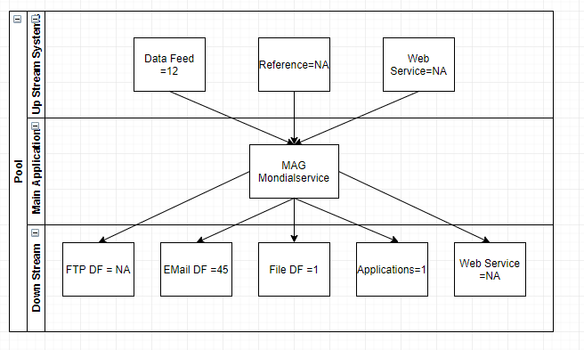

Application Level Dependency
Application name | Application Dependency
MAG Mondialservice | - Unity,  - SAP Console Manager,  - Faxination, Krill,  - Embargo,  - Banchedati, Lunalncarichi,  - Oracle Data Integrator,  - Cardif sinistri,  - XXXX Bonus Drive ,  - Selecta Freccia ,  - Trasmissioni Dati Cedenti ,  - Agenzie Entrate Premi,  - Agenzi Extrate SX,  - NPS, Procedure chiusure ,  - Intrastat ,  - Finiper ,  - ClaimService

Demise Pattern

Job Card
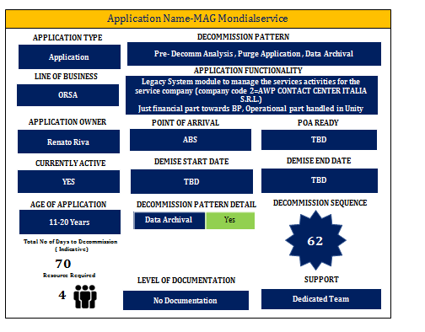

Demise Execution Effort
Total No. of days to decommission (Indicative) | 70 Days

MAG Commerciale
Application Description: Legacy System module to manage the sales activities.
Application parameters based on Interview and Data collection phase:

Type of Application | Custom develop | Business Criticality | Very High
Revenue Impact | Very High | Data Option | Archival
Support Level | Dedicated Team | Documentation | No Documentation

Indexes

Portability Index | 0.7274 | Technical Feasibility Index | 0.6
Risk & Criticality Index | 0.93 | Maintainability Index | 211.93
Language Complexity | 0.428 | Stability | 0.6

Data Feed Dependency
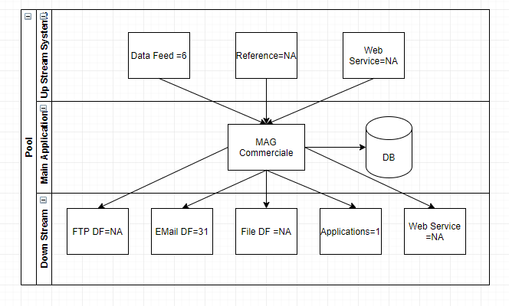

Application Level Dependency
Application name | Application Dependency
MAG Commerciale | - Unity,  - SAP Console Manager,  - Faxination, Krill,  - Embargo,  - Banchedati, Lunalncarichi,  - Oracle Data Integrator,  - Cardif sinistri,  - XXXX Bonus Drive ,  - Selecta Freccia ,  - Trasmissioni Dati Cedenti ,  - Agenzie Entrate Premi,  - Agenzi Extrate SX,  - NPS, Procedure chiusure ,  - Intrastat ,  - Finiper ,  - ClaimService

Demise Pattern

Job card
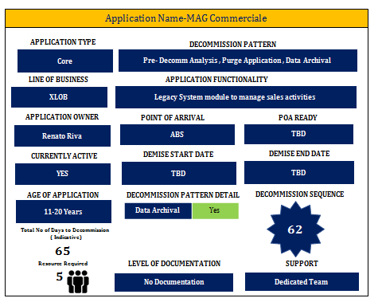

Demise Execution Effort
Total No. of days to decommission (Indicative) | 65 Days

MAG Denuncia Telefonica
Application Description: Legacy System module to manage the data entry of the claims opened by CC operator.

Application parameters based on Interview and Data collection phase:

Type of Application | Custom Develop | Business Criticality | Very High
Revenue Impact | Very High | Data Option | Archival
Support Level | Dedicated Team | Documentation | No Documentation

Indexes

Portability Index | 0.7367 | Technical Feasibility Index | 0.588
Risk & Criticality Index | 0.93 | Maintainability Index | 211.94
Language Complexity | 0.406 | Stability | 0.6

Data Feed Dependency
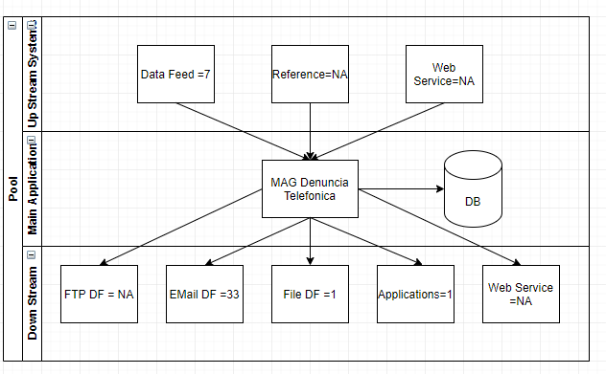

Application Level Dependency
Application name | Application Dependency
MAG Denuncia Telefonica | - Unity,  - SAP Console Manager,  - Faxination, Krill,  - Embargo,  - Banchedati, Lunalncarichi,  - Oracle Data Integrator,  - Cardif sinistri,  - XXXX Bonus Drive ,  - Selecta Freccia ,  - Trasmissioni Dati Cedenti ,  - Agenzie Entrate Premi,  - Agenzi Extrate SX,  - NPS, Procedure chiusure ,  - Intrastat ,  - Finiper ,  - ClaimService

Demise Pattern

Job card
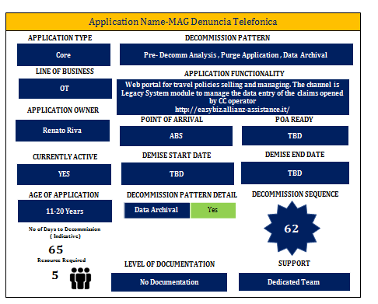

Demise Execution Effort
Total No. of days to decommission (Indicative) | 65 Days

MAG MCC Call center sinistri
Application Description: Legacy System modules to manage the Milan/Casarano call centre activities.

Application parameters based on Interview and Data collection phase:

Type of Application | Custom develop | Business Criticality | Very High
Revenue Impact | Very High | Data Option | Archival
Support Level | Dedicated Team | Documentation | No Documentation

Indexes
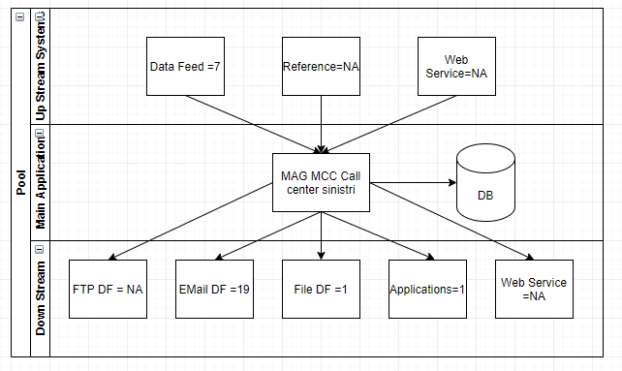
Portability Index | 0.7367 | Technical Feasibility Index | 0.588
Risk & Criticality Index | 0.93 | Maintainability Index | 211.94
Language Complexity | 0.406 | Stability | 0.6

Data Feed Dependency

Application Level Dependency
Application name | Application Dependency
MAG MCC Call center sinistri | - Unity,  - SAP Console Manager,  - Faxination, Krill,  - Embargo,  - Banchedati, Lunalncarichi,  - Oracle Data Integrator,  - Cardif sinistri,  - XXXX Bonus Drive ,  - Selecta Freccia ,  - Trasmissioni Dati Cedenti ,  - Agenzie Entrate Premi,  - Agenzi Extrate SX,  - NPS, Procedure chiusure ,  - Intrastat ,  - Finiper ,  - ClaimService

Demise Pattern

Job card
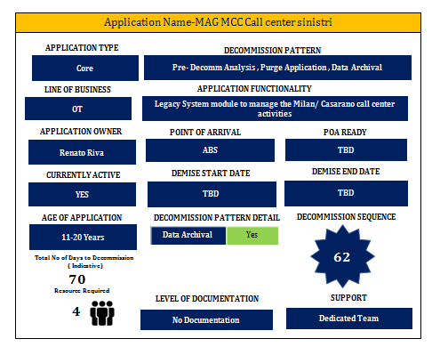

Demise Execution Effort
Total No. of days to decommission (Indicative) | 70 Days

MAG Assunzioni
Application Description: Legacy System module to manage underwriting activities.
Application parameters based on Interview and Data collection phase:

Type of Application | Custom develop | Business Criticality | Very High
Revenue Impact | Very High | Data Option | Archival
Support Level | Shared Team | Documentation | No Documentation

Indexes
Portability Index | 0.7565 | Technical Feasibility Index | 0.542
Risk & Criticality Index | 0.93 | Maintainability Index | 214.65
Language Complexity | 0.314 | Stability | 0.2

Data Feed Dependency
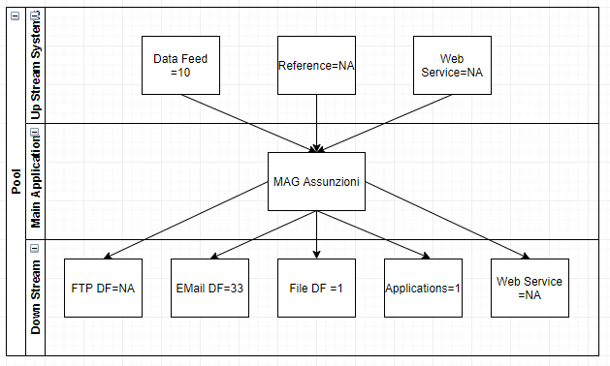

Application Level Dependency
Application name | Application Dependency
MAG Assunzioni | - Unity,  - SAP Console Manager,  - Faxination, Krill,  - Embargo,  - Banchedati,  - Lunalncarichi,  - Oracle Data Integrator,  - Cardif sinistri,  - XXXX Bonus Drive ,  - Selecta Freccia ,  - Trasmissioni Dati Cedenti ,  - Agenzie Entrate Premi,  - Agenzi Extrate SX,  - NPS,  - Procedure chiusure ,  - Intrastat ,  - Finiper ,  - ClaimService

Demise Pattern

Job card

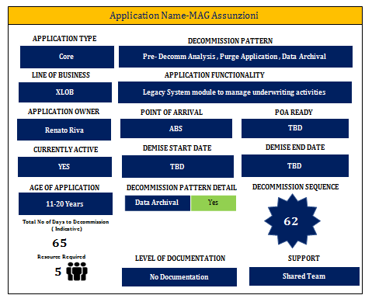

Demise Execution Effort
Total No. of days to decommission (Indicative) | 65 Days

MAG MCC Assistenza Clienti
Application Description: Legacy System modules to manage the Casarano call centre activities.

Application parameters based on Interview and Data collection phase:

Type of Application | Custom Develop | Business Criticality | Very High
Revenue Impact | Very High | Data Option | Archival
Support Level | Dedicated Team | Documentation | No Documentation

Indexes

Portability Index | 0.7367 | Technical Feasibility Index | 0.588
Risk & Criticality Index | 0.93 | Maintainability Index | 211.94
Language Complexity | 0.406 | Stability | 0.6

Data Feed Dependency
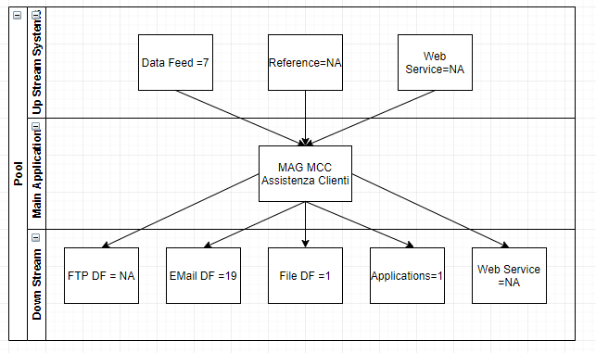

Application Level Dependency
Application name | Application Dependency
MAG MCC Assistenza Clienti | - Unity,  - SAP Console Manager,  - Faxination, Krill,  - Embargo,  - Banchedati,  - Lunalncarichi,  - Oracle Data Integrator,  - Cardif sinistri,  - XXXX Bonus Drive ,  - Selecta Freccia ,  - Trasmissioni Dati Cedenti ,  - Agenzie Entrate Premi,  - Agenzi Extrate SX, NPS,  - Procedure chiusure ,  - Intrastat ,  - Finiper ,  - ClaimService

Demise Pattern

Job card

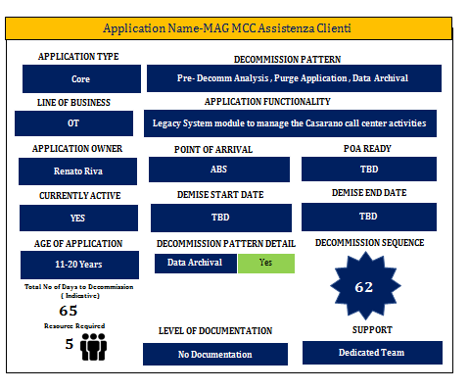

Demise Execution Effort
Total No. of days to decommission (Indicative) | 65 Days

MAG Ced
Application Description: Application is to manage ICT activities.

Application parameters based on Interview and Data collection phase:

Type of Application | Custom develop | Business Criticality | Very High
Revenue Impact | Very High | Data Option | Archival
Support Level | Dedicated Team | Documentation | No Documentation

Indexes
Portability Index | 0.6387 | Technical Feasibility Index | 0.572
Risk & Criticality Index | 0.93 | Maintainability Index | 213.12
Language Complexity | 0.372 | Stability | 0.8

Data Feed Dependency

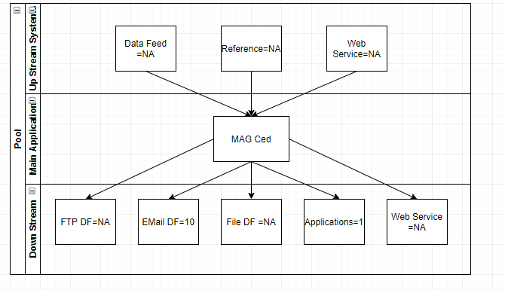

Application Level Dependency

Application name | Application Dependency
MAG Ced | - Unity,  - SAP Console Manager,  - Faxination, Krill,  - Embargo,  - Banchedati, Lunalncarichi,  - Oracle Data Integrator,  - Cardif sinistri,  - XXXX Bonus Drive ,  - Selecta Freccia ,  - Trasmissioni Dati Cedenti ,  - Agenzie Entrate Premi,  - Agenzi Extrate SX,  - NPS,  - Procedure chiusure ,  - Intrastat ,  - Finiper ,  - ClaimService

Demise Pattern

Job card

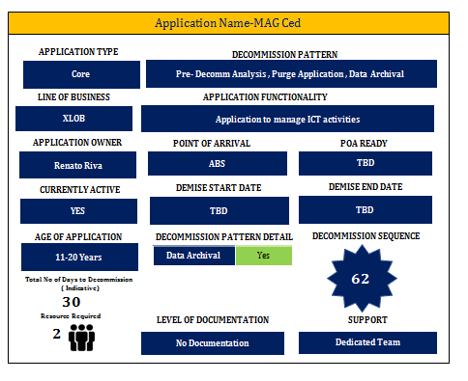

Demise Execution Effort
Total No. of days to decommission (Indicative) | 30 Days

MAG Divisione Salute
Application Description: Application for health department claim handling. Used for Health service (e.g. XXXX illness insurance). Uses email and fax to communicate with hospitals.(booking rooms/terapy) gets the provider invoice and send it to XXXX application “Sirio” which performs the payment.
Application parameters based on Interview and Data collection phase:

Type of Application | Custom develop | Business Criticality | High
Revenue Impact | High | Data Option | Retain
Support Level | Shared Team | Documentation | No Documentation

Indexes

Portability Index | 0.7182 | Technical Feasibility Index | 0.648
Risk & Criticality Index | 0.97 | Maintainability Index | 198.84
Language Complexity | 0.41 | Stability | 0.8

Data Feed Dependency
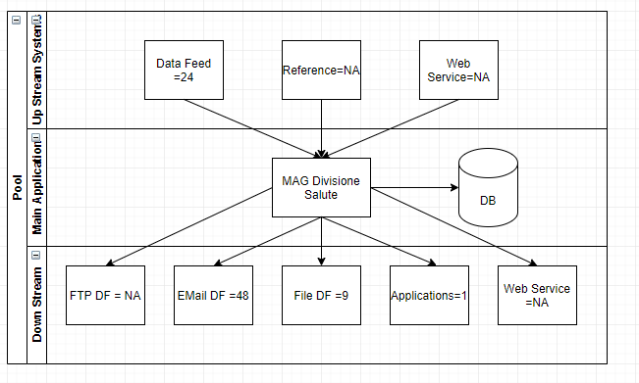

Application Level Dependency
Application name | Application Dependency
MAG Divisione Salute | - Unity,  - SAP Console Manager,  - Faxination, Krill,  - Embargo,  - Banchedati,  - Lunalncarichi,  - Oracle Data Integrator,  - Cardif sinistri,  - XXXX Bonus Drive ,  - Selecta Freccia ,  - Trasmissioni Dati Cedenti ,  - Agenzie Entrate Premi,  - Agenzi Extrate SX,  - NPS,  - Procedure chiusure ,  - Intrastat ,  - Finiper ,  - ClaimService

Demise Pattern

Job Card
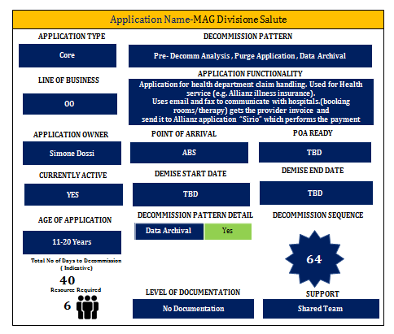

Demise Execution Effort
Total No. of days to decommission (Indicative) | 40 Days

Faxination
Application Description: FAX/SMS delivery, Handles outgoing SMS and Fax and incoming Fax. For Claim fax lines the fax is sent to DEM. For Assistance fax lines the fax is sent to Unity. Connected to Unity and MAG (for MAG through Exchange for outgoing Fax and Polling service for outgoing SMS).
Application parameters based on Interview and Data collection phase:

Type of Application | 3rd Party | Business Criticality | High
Revenue Impact | Medium | Data Option | NA
Support Level | NA | Documentation | No Documentation

Indexes

Portability Index | 0.7182 | Technical Feasibility Index | 0.648
Risk & Criticality Index | 0.86 | Maintainability Index | 198.84
Language Complexity | 0.41 | Stability | 0.2

Data Feed Dependency
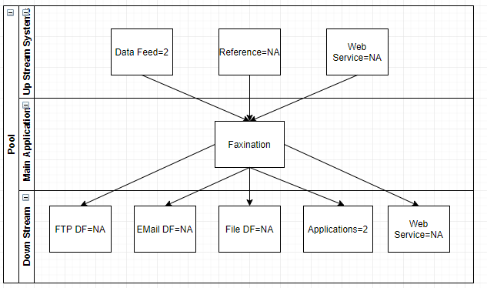

Application Level Dependency
Application name | Application Dependency
Faxination | Unity and MAG Application

Demise Pattern

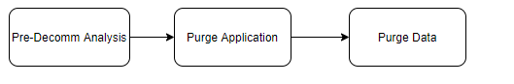

Job Card

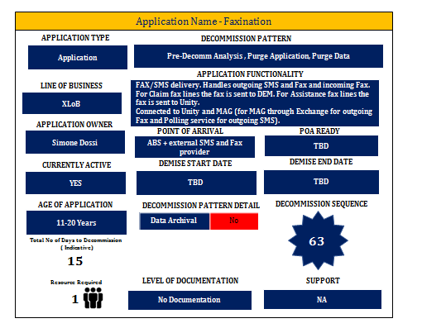

Demise Execution Effort
Total No. of days to decommission (Indicative) | 15 Days

Procedure chiusure mensili
Application Description: Group of procedures needed to close the month (reports, registry, etc...) Part of Oracle data integrator.

Application parameters based on Interview and Data collection phase:

Type of Application | Custom develop | Business Criticality | Medium
Revenue Impact | Medium | Data Option | NA
Support Level | NA | Documentation | No Documentation

Indexes

Portability Index | 0.8023 | Technical Feasibility Index | 0.588
Risk & Criticality Index | 0.66 | Maintainability Index | 194.15
Language Complexity | 0.578 | Stability | 0.2

Data Feed Dependency
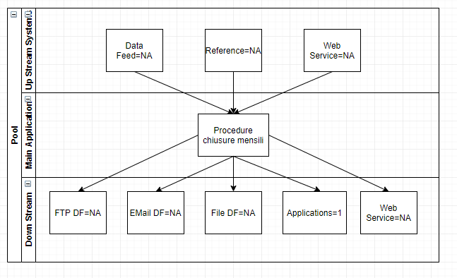

Application Level Dependency
Application name | Application Dependency
Procedure chiusure mensili | MAG

Demise Pattern

Job Card
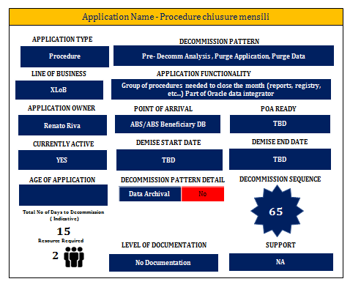

Demise Execution Effort
Total No. of days to decommission (Indicative) | 15 Days

MagXXXXDs_WS_Proxy
Application Description: Web Service that connects MAG Divisione Salute with XXXX system, medical case.
Application parameters based on Interview and Data collection phase:

Type of Application | Custom Develop | Business Criticality | Medium
Revenue Impact | Medium | Data Option | NA
Support Level | Shared Team | Documentation | Minimal Documentation

Indexes

Portability Index | 0.8216 | Technical Feasibility Index | 0.5
Risk & Criticality Index | 0.48 | Maintainability Index | 185.05
Language Complexity | 0.486 | Stability | 0.8

Data Feed Dependency
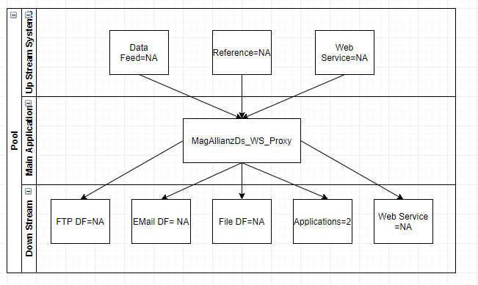

Application Level Dependency
Application name | Application Dependency
MagXXXXDs_WS_Proxy | MAG
MagXXXXDs_WS_Proxy | Unity (cluster 6)

Demise Pattern

To Be Decided (TBD)

Job Card

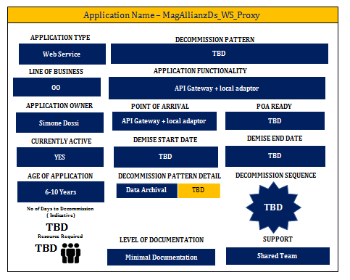

Demise Execution Effort
Total No. of days to decommission (Indicative) | TBD

Selecta Freccia
Application Description: Application to send documents that will be printed and dispatched to clients.

Application parameters based on Interview and Data collection phase:

Type of Application | Custom develop | Business Criticality | Medium
Revenue Impact | Low | Data Option | Archival
Support Level | Dedicated Team | Documentation | No Documentation

Indexes

Portability Index | 0.9108 | Technical Feasibility Index | 0.618
Risk & Criticality Index | 0.13 | Maintainability Index | 202.48
Language Complexity | 0.35 | Stability | 0.2

Data Feed Dependency
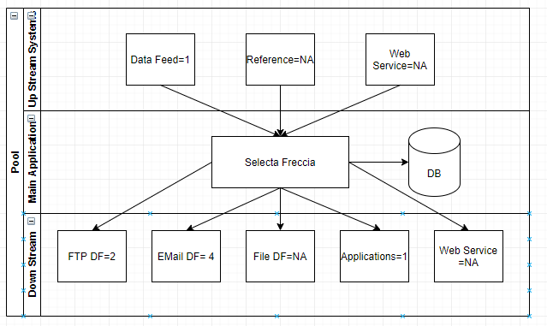

Application Level Dependency
Application name | Application Dependency
Selecta Freccia | MAG

Demise Pattern
To Be Decided (TBD)

Job Card

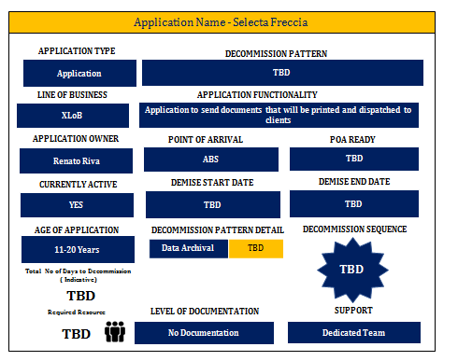

Demise Execution Effort

Total No. of days to decommission (Indicative) | TBD

Agenzie Entrate Premi
Application Description: Application to generate reporting for Fraud control Government agency.
Application parameters based on Interview and Data collection phase:

Type of Application | Custom develop and 3rd party | Business Criticality | High
Revenue Impact | Low | Data Option | Retain
Support Level | Dedicated Team | Documentation | Minimal Documentation

Indexes

Portability Index | 0.6968 | Technical Feasibility Index | 0.514
Risk & Criticality Index | 0.31 | Maintainability Index | 189.7
Language Complexity | 0.428 | Stability | 0.8

Data Feed Dependency
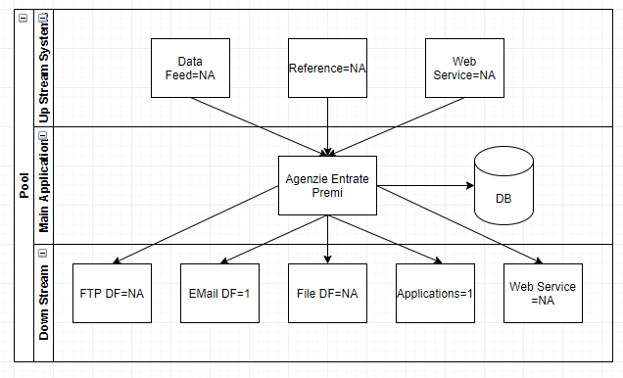

Application Level Dependency
Application name | Application Dependency
Agenzie Entrate Premi | MAG

Demise Pattern
To Be Decided (TBD)

Job Card

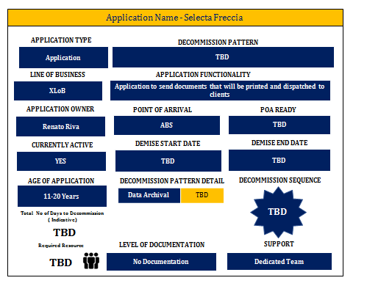

Demise Execution Effort
Total No. of days to decommission (Indicative) | TBD

Agenzie Entrate SX
Application Description: Application to generate reporting for Fraud control Government agency.
Application parameters based on Interview and Data collection phase:

Type of Application | Custom develop | Business Criticality | Medium
Revenue Impact | Low | Data Option | Retain
Support Level | Shared Team | Documentation | Minimal Documentation

Indexes

Portability Index | 0.8437 | Technical Feasibility Index | 0.514
Risk & Criticality Index | 0.28 | Maintainability Index | 189.7
Language Complexity | 0.428 | Stability | 0.8

Data Feed Dependency
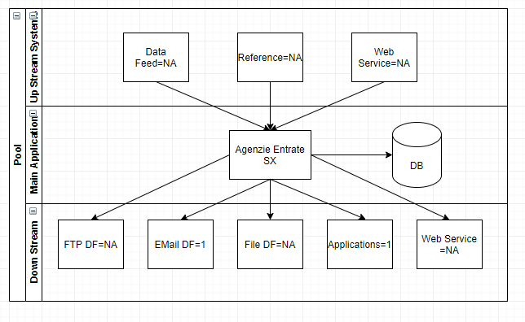

Application Level Dependency
Application name | Application Dependency
Agenzie Entrate SX | Agenzia Entrate Integration (Out of Scope)
Agenzie Entrate SX | MAG

Demise Pattern
To Be Decided (TBD)

Job Card

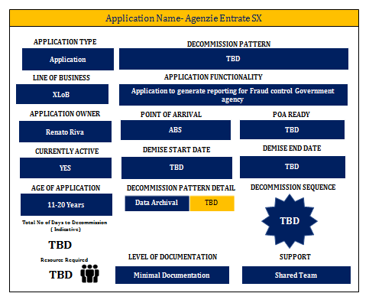

Demise Execution Effort

Total No. of days to decommission (Indicative) | TBD

Intrastat
Application Description: Reporting for Government agency collecting all EU invoices.
Application parameters based on Interview and Data collection phase:

Type of Application | 3rd party | Business Criticality | High
Revenue Impact | Low | Data Option | Archival
Support Level | Shared Team | Documentation | Minimal Documentation

Indexes

Portability Index | 0.7763 | Technical Feasibility Index | 0.514
Risk & Criticality Index | 0.31 | Maintainability Index | 185.04
Language Complexity | 0.514 | Stability | 0.8

Data Feed Dependency
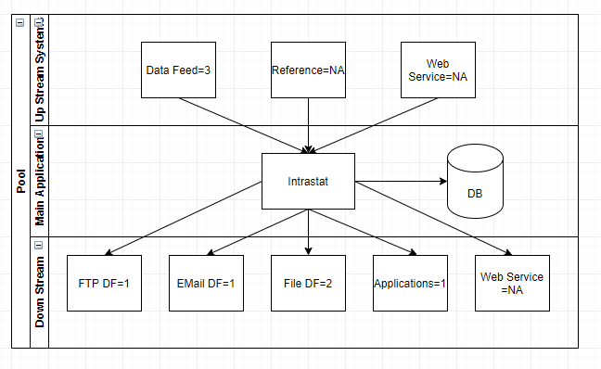

Application Level Dependency
Application name | Application Dependency
Intrastat | Intrastat Integration (Fatture Attive), Intrastat Integration (Fatture Passive) (Out of Scope)
Intrastat | MAG

Demise Pattern

To Be Decided (TBD)

Job Card

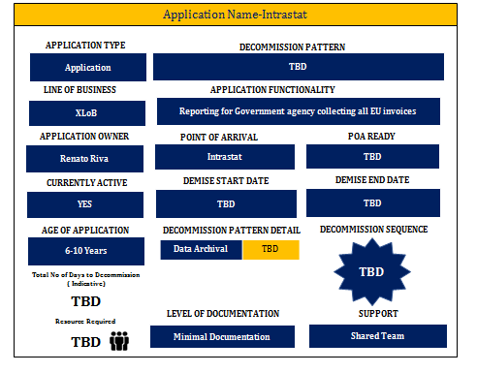

Demise Execution Effort
Total No. of days to decommission (Indicative) | TBD

GRP
Application Description: GRP is a Group Accounting System.

Application parameters based on Interview and Data collection phase:

Type of Application | Custom develop | Business Criticality | Very High
Revenue Impact | Very High | Data Option | Retain
Support Level | NA | Documentation | NA

Indexes
Portability Index | 0.8562 | Technical Feasibility Index | 0.472
Risk & Criticality Index | 0.73 | Maintainability Index | 209.22
Language Complexity | 0.256 | Stability | 0.2

Data Feed Dependency
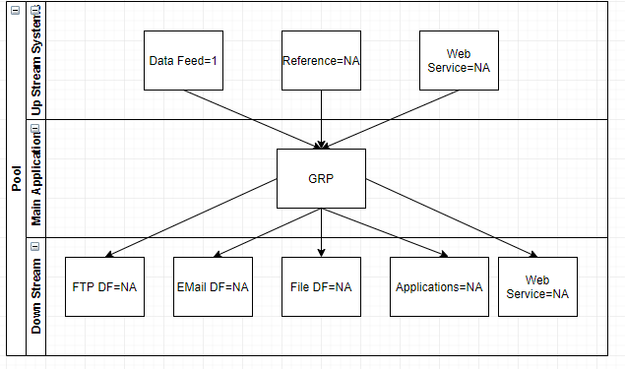

Application Level Dependency
Application name | Application Dependency
GRP | Sap Console Manager

Demise Pattern
To Be Decided (TBD)

Job Card
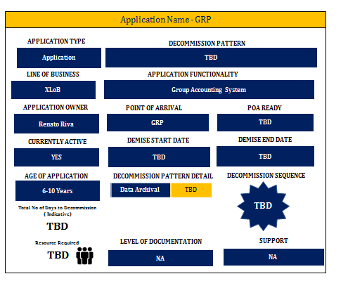

Demise Execution Effort
Total No. of days to decommission (Indicative) | TBD

Krill
Application Description: Application for substitute optical storage.

Application parameters based on Interview and Data collection phase:

Type of Application | 3rd party | Business Criticality | Medium
Revenue Impact | Low | Data Option | NA
Support Level | Shared Team | Documentation | No Documentation

Indexes

Portability Index | 1 | Technical Feasibility Index | 0.236
Risk & Criticality Index | 0.28 | Maintainability Index | 197.21
Language Complexity | 0.444 | Stability | 0.2

Data Feed Dependency
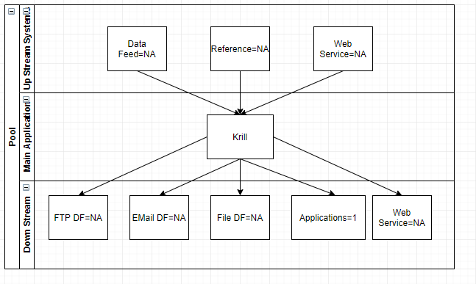

Application Level Dependency
Application name | Application Dependency
Krill | MAG

Demise Pattern
To Be Decided (TBD)

Job Card

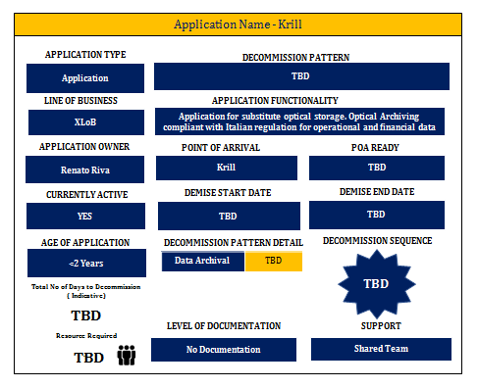

Demise Execution Effort
Total No. of days to decommission (Indicative) | TBD

APPENDIX

Demise Pattern
The Demise Pattern helps to understand Pre-Decom, Build Difference, If Data/User needs to be migrated, Purge the data if needed. Below 3 patterns are derived based on the information available.
Pattern 1 - Pre-DecommAnalysis, Purge Application, Data Archival
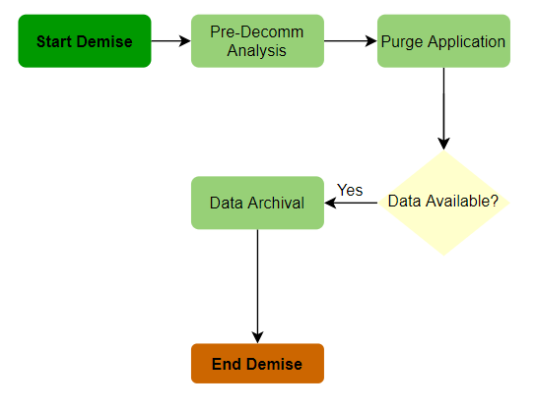

Pattern 2–Pre-DecommAnalysis, Purge Application, Purge Data
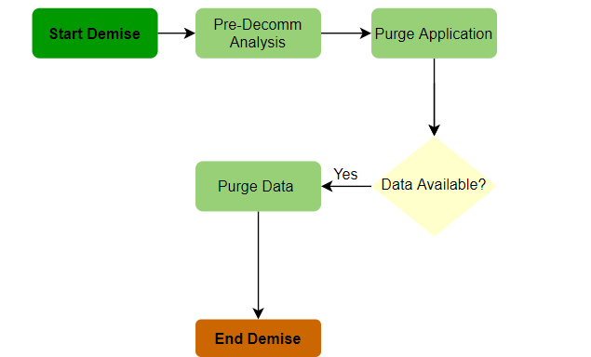
Pattern 3- Pre-DecommAnalysis, Purge Application,Retain Data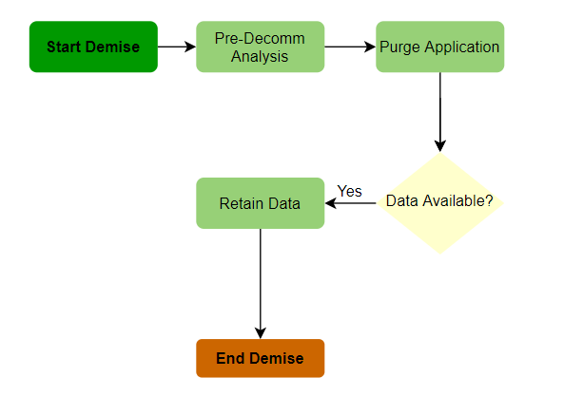

About Capgemini
Withmorethan190,000people,Capgeminiispresentinover40countriesandcelebrates its50thAnniversaryyearin2017.Agloballeaderinconsulting,technologyandoutsourcing services,theGroupreported2016globalrevenuesofEUR12.5billion.Togetherwithits clients,Capgeminicreatesanddeliversbusiness,technologyanddigitalsolutionsthatfit
theirneeds,enablingthemtoachieveinnovationandcompetitiveness.Adeeplymulticultural organization, Capgemini has developed its own way of working, the Collaborative Business Experience™,anddrawsonRightshore®,itsworldwidedeliverymodel.
Learnmoreaboutusat
www.capgemini.com

TeamName_Date_Designer

About Capgemini

A global leader in consulting, technology services and digital transformation, Capgemini is at the forefront of innovation to address the entire breadth of clients’ opportunities in the evolving world of cloud, digital and platforms. Building on its strong 50-year heritage and deep industry-specific expertise, Capgemini enables organizations to realize their business ambitions through an array of services from strategy to operations. Capgemini is driven by the conviction that the business value of technology comes from and through people. It is a multicultural company of 200,000 team members in over 40 countries. The Group reported 2016 global revenues of EUR 12.5 billion.
www.capgemini.com

This message contains information that may be privileged or confidential and is the property of the Capgemini Group.
Copyright © 2020 Capgemini. All rights reserved.

